

**UNIVERSIDAD TECNOLÓGICA DE**

**SAN LUIS RIO COLORADO**

**PRACTICA 2**

**MTRO. RICADO ALEJANDRO SOTO MORALES**

**AUTOR: VICTOR MANUEL GALVAN COVARRUBIAS**

San Luis Rio Colorado, Sonora Junio, 2020

**Use cases for ACME company**

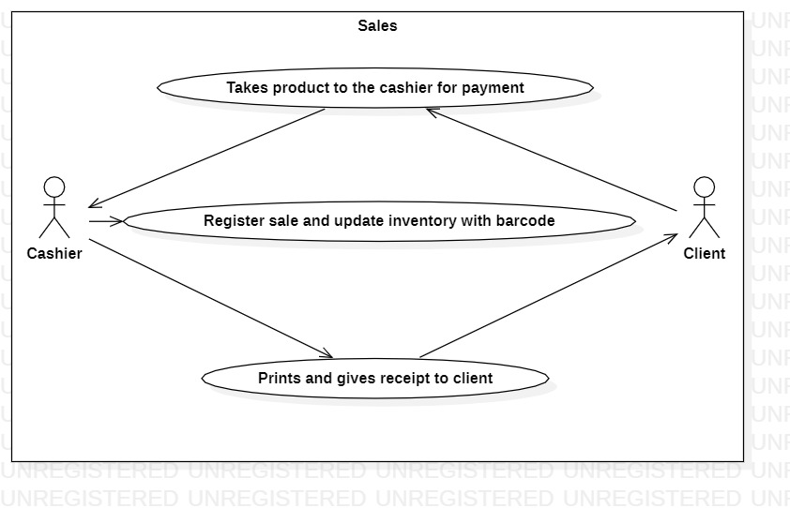

Illustration 1: Use case corresponding to the ACME system sales module

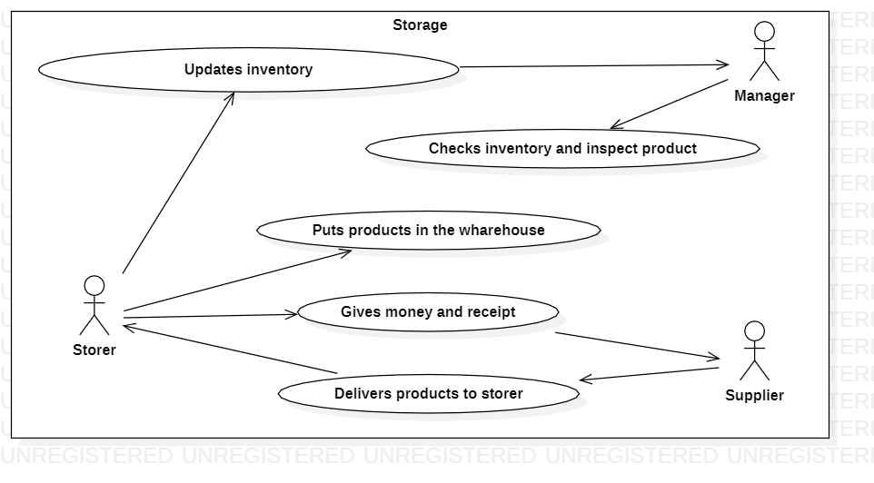

Illustration 2: Use case corresponding to the ACME system storage module

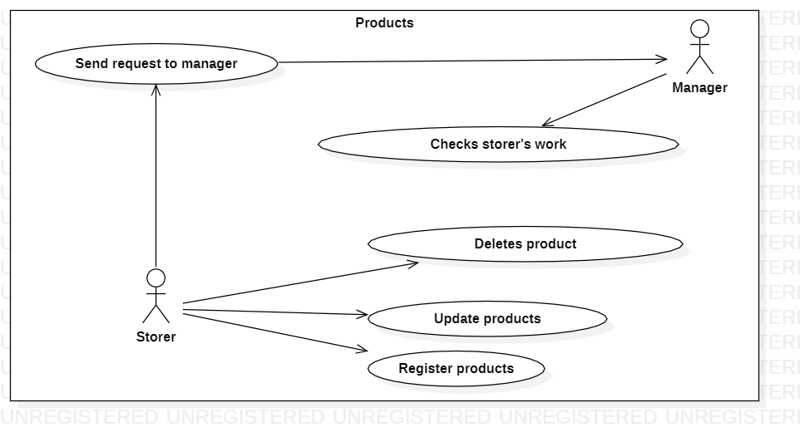

Illustration 3: Use case corresponding to the ACME system products module

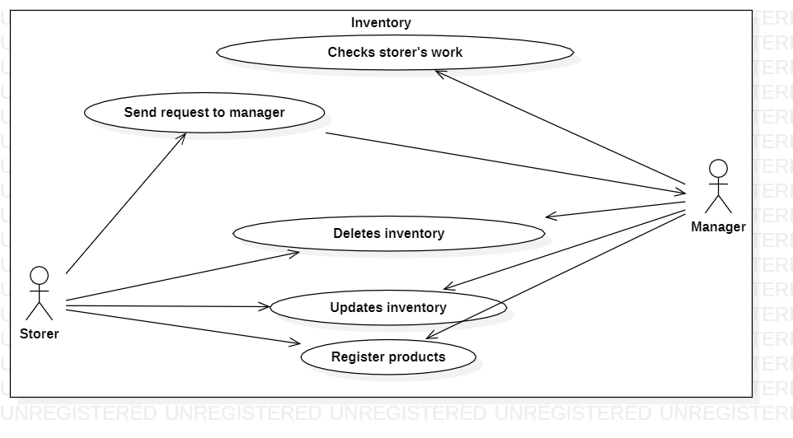

Illustration 4: Use case corresponding to the ACME system inventory module

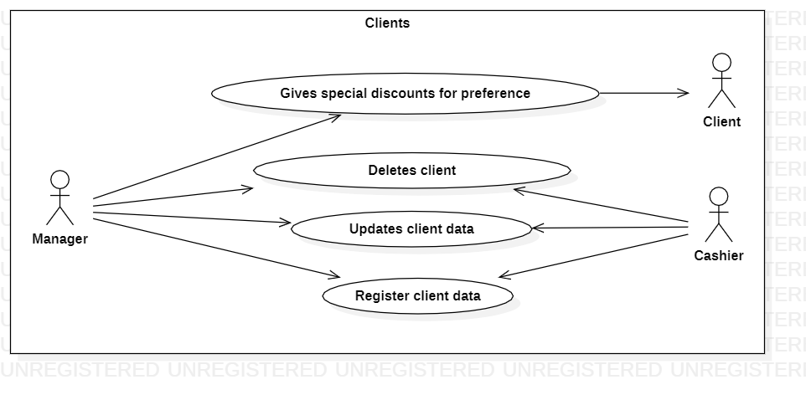

Illustration 5: Use case corresponding to the ACME system clients module

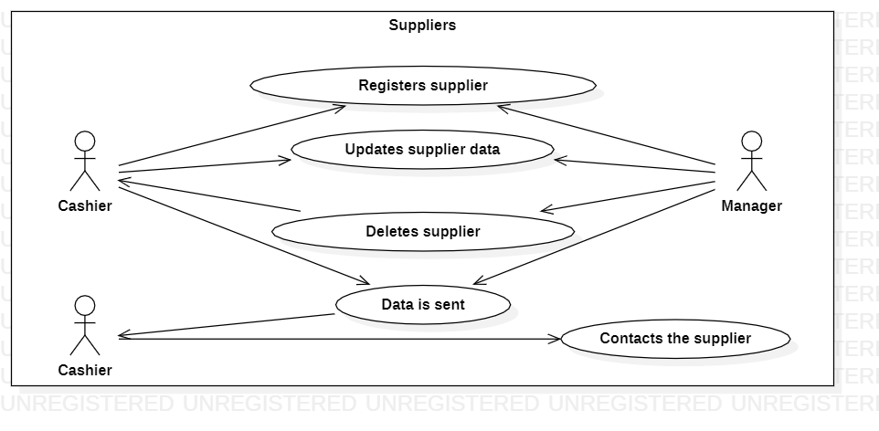

Illustration 6: Use case corresponding to the ACME system suppliers module

**Use cases for SIAGE class**

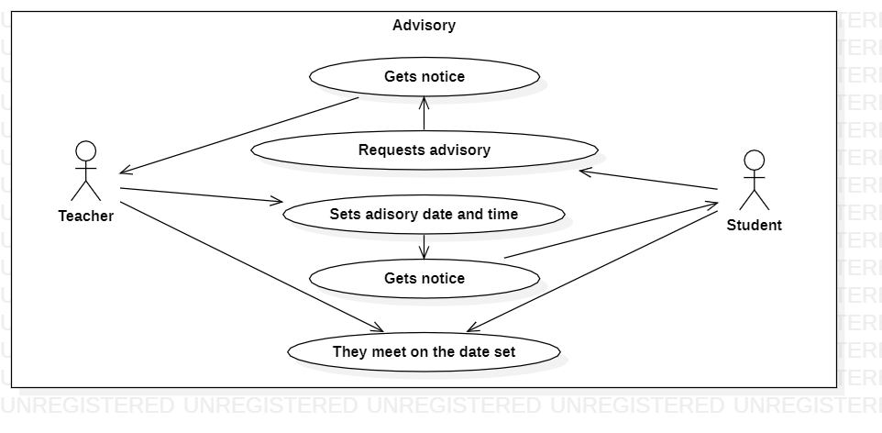

Ilustration 1: Use case corresponding to the SIAGE Class System advisory module

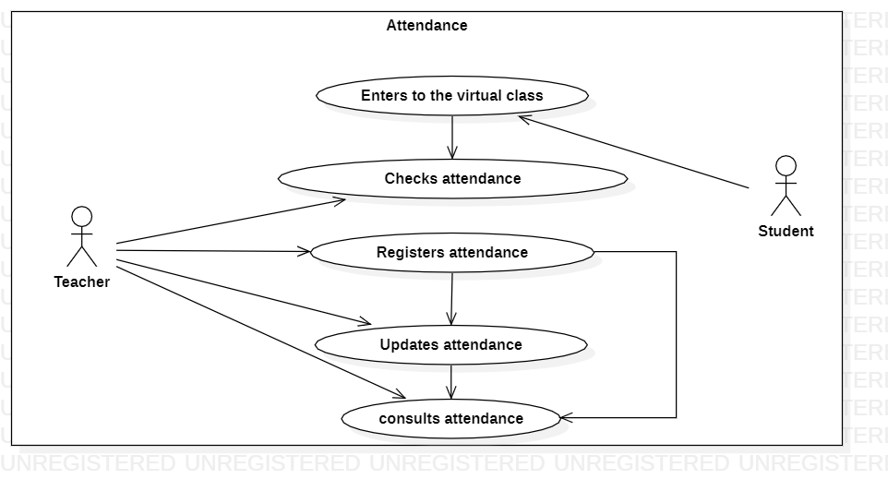

Ilustration 2: Use case corresponding to the SIAGE Class System attendance module

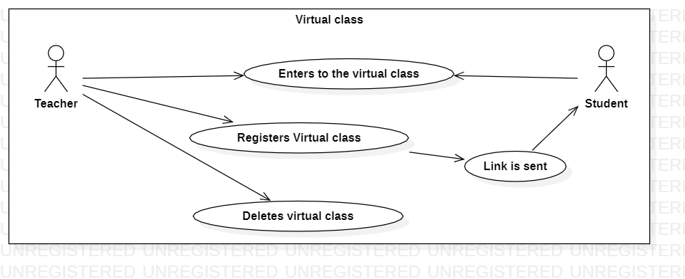

Ilustration 3: Use case corresponding to the SIAGE Class System virtual class module

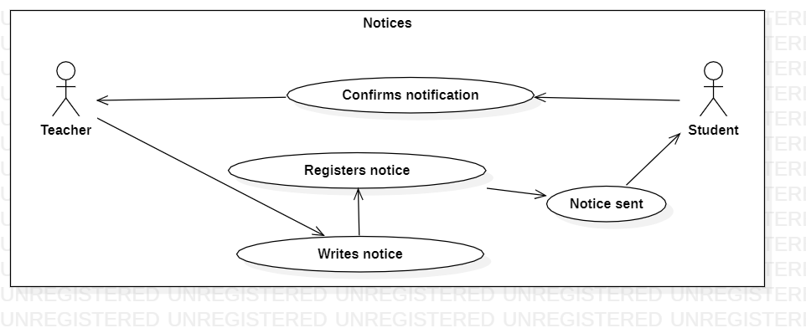

Ilustration 4: Use case corresponding to the SIAGE Class System notices module

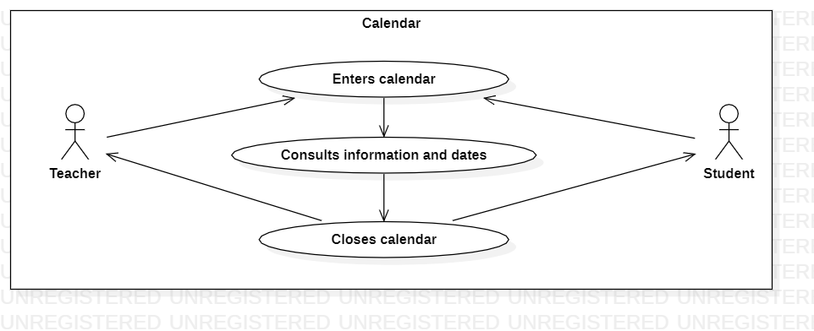

Ilustration 5: Use case corresponding to the SIAGE Class System calendar module

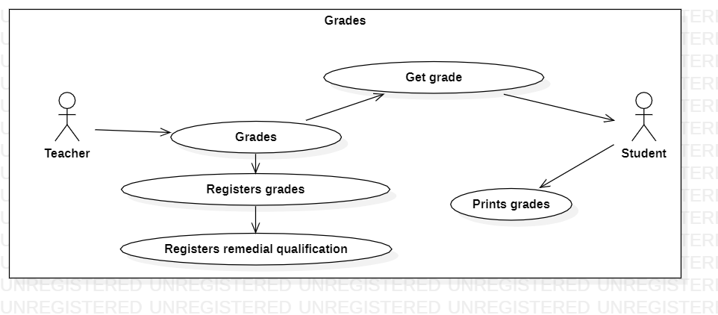

Ilustration 6: Use case corresponding to the SIAGE Class System grades module

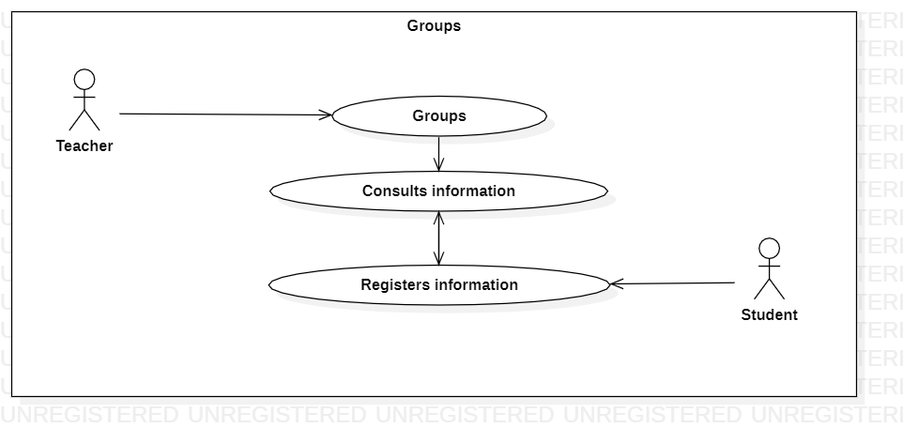

Ilustration 7: Use case corresponding to the SIAGE Class System groups module

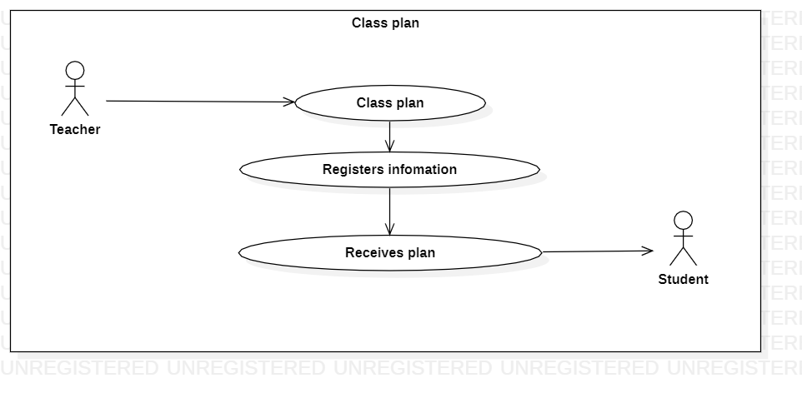

Ilustration 8: Use case corresponding to the SIAGE Class System class plan module

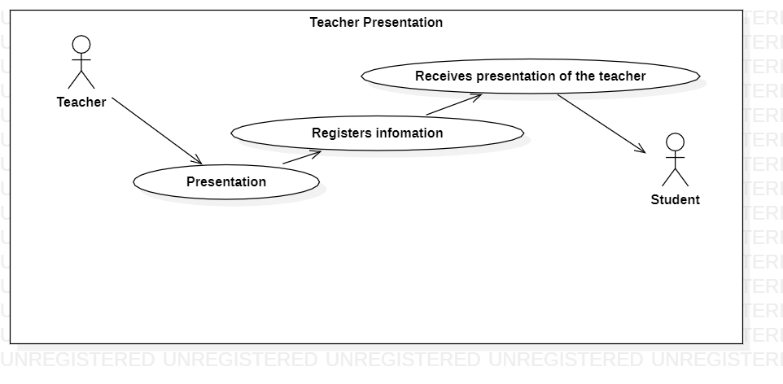

Ilustration 9: Use case corresponding to the SIAGE Class System teacher presentation module

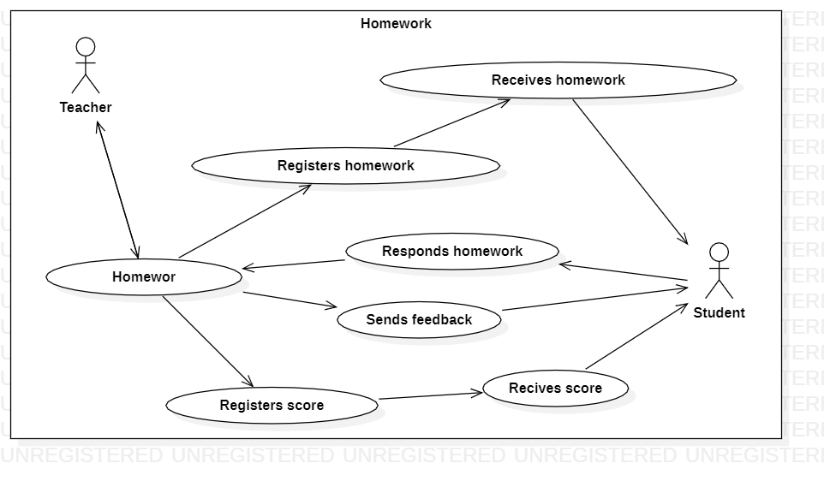

Ilustration 10: Use case corresponding to the SIAGE Class System homework module